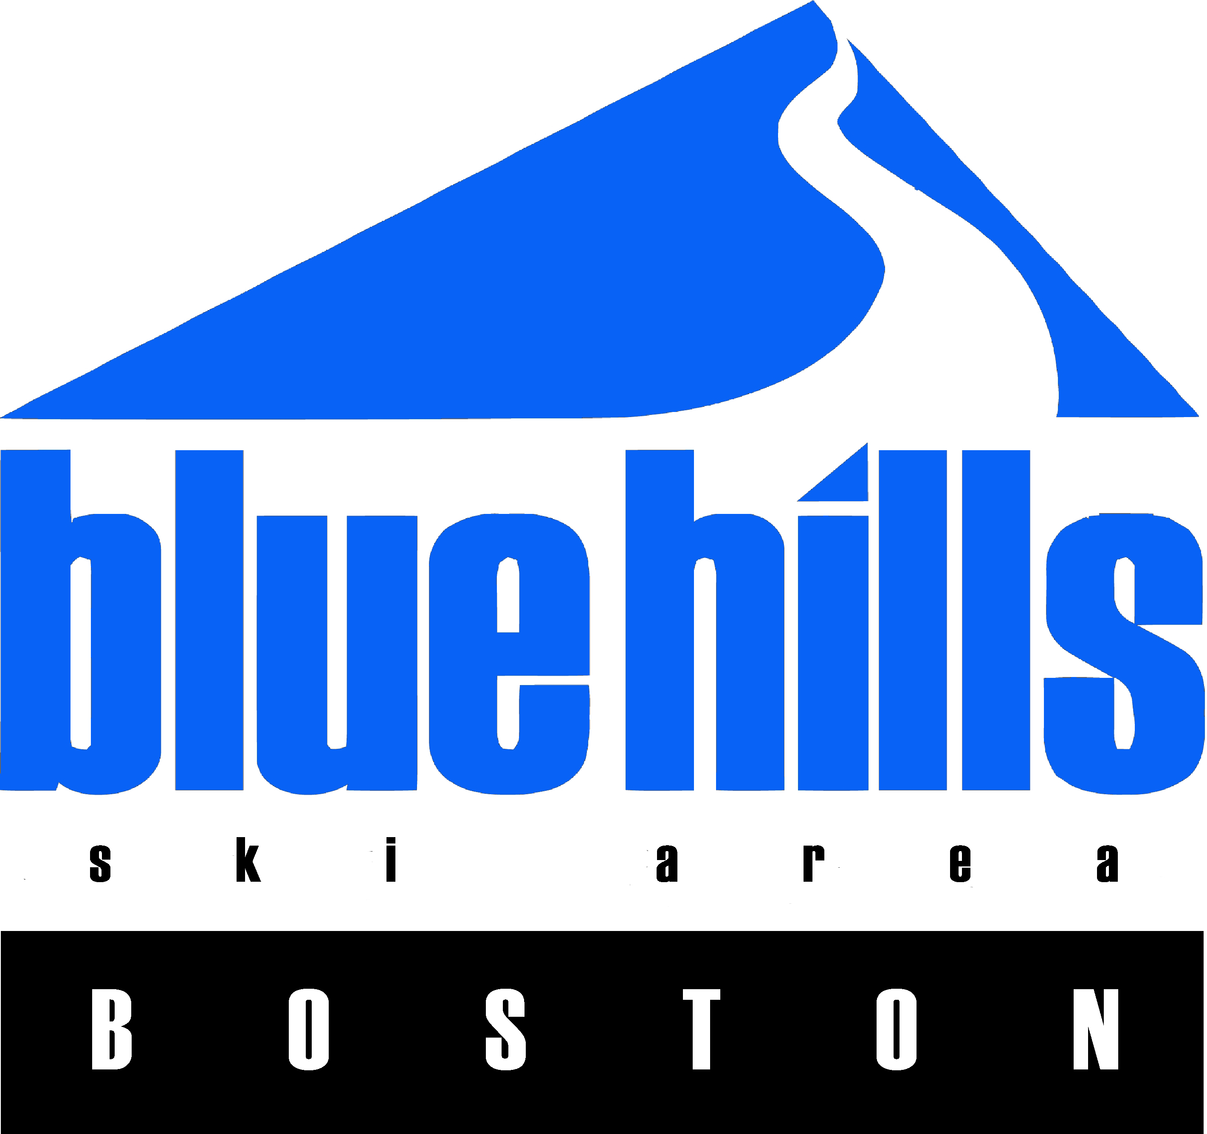
17$18 PROGRAM EQUIPMENT AGREEMENT:
NAME AND INFORMATION OF PARENT OR GUARDIAN OF MINOR RENTING EQUIPMENT.
LAST NAME
FIRST NAME
STATE DRIVERS LIC #
DATE
STREET ADDRESS
CITY
STATE
ZIP
CELL PHONE EMAIL

CHILD’S INFORMATION – ALL INFORMATION MUST BE COMPLETED AND ACCURATE
FIRST NAME
LAST NAME
AGE
MALE

FEMALE 
HEIGHT
FT
IN
WEIGHT
LBS
Shoe Size
U.S.
CIRCLE SKIER TYPE
I II III
Type I > Cautious skiers on smooth slopes of gentle to moderate steepness. Type II > Skiers not classified as type I or III
Type III > Skiers who prefer fast skiing on slopes of moderate to steep pitch.
SNOWBOARD ONLY: I prefer my LEFT RIGHT (circle one) foot forward on the Snowboard
2021-2022 Program Rental Form and Waiver

What is my skier type? Selecting your skier type is your responsibility.
Your skier type, height, age and ski boot sole length are used by our shop technicians to determine the release/retention settings of your bindings. It is important to provide accurate information. Inaccurate information may increase your of injury. Consult these descriptions to select your skier type:
Type 1
- Ski cautiously.
- Prefer lower speeds.
- Prefer cautious skiing on smooth slope or gentle to moderate pitch.
- Prefer lower than average release/retention settings.
- Prefer increased risk of inadvertent binding release in order to gain increased releasability in a fall.
- Entry level skiers uncertain of their classification.
Type II
- Ski moderately.
- Prefer to ski on varied terrain
- Skiers not classified Type I or Type III
- Prefer average release retention settings appropriate for most recreational skiing.
Type III
- Ski aggressively.
- Prefer fast and aggressive skiing on slopes of moderate to steep pitch.
- Prefer higher than average release/retention settings.
- Prefer decreased releasability in a fall in order to gain decreased risk of inadvertent binding release.

Type I>: skiers who desire lower release/retention settings that Type I and will further increase the risk of inadvertent binding release in order to gain increased releasability in a fall.
Type III+: skiers who desire higher release/retention settings that Type III and will further decrease the risk of inadvertent binding release in order to gain decreased risk of inadvertent bindings release.

RELEASE, ASSUMPTION OF RISK, INDEMNITY & RENTAL AGREEMENT PLEASE READ FRONT AND BACK CAREFULLY BEFORE SIGNING

- I agree, for myself and/or my child, to RELEASE, forever indemnify, defend, and hold harmless Ski Blue Hills Management, LLC, the ski shop, and all other persons and companies who provide any equipment, services or facilities or have any involvement in manufacturing, distributing, selling, renting, mounting, adjusting, servicing, maintaining, testing or inspecting any equipment provided under this agreement, and all of their agents, employees, volunteers, officers, directors, owners and affiliated companies, and their successors and assigns (collectively referred to as “RELEASEES”), from liability for any and all injury, illness (including but not limited to COVID-19), disability, loss, damage or death to myself or to my child, or damage to my or my child’s property, or to any other person, resulting from the RELEASEES’ NEGLIGENCE or any other cause. I understand that the RELEASEES are not responsible for the consequences of their own NEGLIGENCE, that is, their failure to use reasonable care in any way. I acknowledge that I am freely and expressly assuming and accepting any and all risks of property damage, personal injury, illness (including but not limited to COVID-19), disability and death in connection with my or my child’s use of the rental equipment, the resort or the snow tubing facility. This releases all claims, including those of which I and/or my child am not aware and those not mentioned in this release. This release applies to all past, present and future claims, including but not limited to claims resulting from anything which has happened to now, or which may happen in the future.
Please complete front and back of this agreement. Agreement must be signed to be valid.

- I further agree, for myself and/or my child, to release and give up any and all claims and rights that I and/or my child may have against Ski Blue Hills Management, LLC and the other RELEASEES named in this agreement, in any way arising out of, relating to or in connection with the manufacturing, distributing, selling, renting, mounting, adjusting, servicing, maintaining, testing or inspecting of any equipment provided under this agreement. This releases all claims, including those of which
I and/or my child am not aware and those not mentioned in this release. This release applies to all past, present and future claims, including but not limited to claims resulting from anything which has happened to now, or which may happen in the future.

- For myself, my child, and our heirs and assigns, I agree to RELEASE, indemnify, defend, and hold harmless the RELEASEES from any and all loss or damage that I or my child may cause to persons or property while using the ski area and the resort. This includes, but is not limited to, any and all claims for personal injury, illness (including but not limited to COVID-190, disability, death and/or property damage that may in any way arise out of use of the resort.

- I acknowledge that the reverse side of this form shall be completed prior to the rental of any equipment, and shall become a part of this Agreement. I hereby represent that all information provided on said Agreement Form shall be accurate.

- I acknowledge that it is the skier’s responsibility to verify that the binding indicators match the settings indicated on the rental equipment identification tag provided with the equipment. I agree that I will verify the binding indicators before using equipment provided to me, and authorize my minor child to verify the binding indicators before using equipment provided to him/her. If the indicators do not match the settings on the rental equipment identification tag, neither I nor my child will use the equipment until a Blue Hills rental technician has made the proper adjustment(s), and the adjusted settings have been verified by me or my child. I acknowledge that any use of rental equipment with settings which do not match those indicated on the identification tag shall be at the skier’s own risk, and that the RELEASEES shall not be liable for any personal injury, death and/or property damage which may result from the use of such equipment by me or my child.

- I accept for use “as is” the equipment provided and accept full responsibility for the care of the equipment while it is in my and/or my minor child’s possession. I will be responsible for the replacement at full retail value of any equipment rented under this form, but not returned to the shop. I agree to return all rental equipment by the agreed date in clean condition to avoid any additional charges. If any of this equipment is damaged or involved in any kind of accident, I will stop using it immediately, return it to the shop and report the accident or damage.

- I understand that there are inherent and other risks involved in the sport of snow skiing or snowboarding, for which this equipment is to be used, that injuries are a common and ordinary occurrence of the sport, and I freely and voluntarily assume those risks.

- HELMET I understand that the helmet provided cannot guarantee the user’s safety. The helmet may reduce the risk or severity of injury to certain parts of the head that are covered by the helmet, but it DOES NOT REDUCE THE RISK of injuries to any part of the user’s body. I ASSUME ALL RISKS of personal injury and/or death arising from use of helmet.

- ALPINE SKI I understand that a ski-binding-boot system will not release or retain at all times or under all circumstances where release or retention may prevent injury or death, nor is it possible to predict every situation in which it will release or retain, and it is, therefore, no guarantee of the skier’s safety. I further understand and agree that unwanted release or retention of bindings is an inherent and assumed risk of skiing.

- SNOWBOARD SKI I understand that any snowboard skiing equipment being furnished forms a part or all of a snowboard/boot/binding system which is a NON-RELEASE system, that its use cannot guarantee the user’s safety and that this snowboard/boot/binding system DOES NOT REDUCE THE RISK of injuries to any part of the user’s body, and that these features are inherent and assumed risks of snowboarding.

- With regard to any equipment provided under this agreement at any time during the season, I hereby ASSUME ALL RISKS AND I RELEASE from any legal liability the RELEASEES from any and all responsibility or legal liability for claims asserted by anyone arising out of any injuries, illness (including but not limited to COVID-19), disability, damages or death to my child, to me or to any other person who uses this equipment, whether caused by NEGLIGENCE or any other cause. I further agree that neither I nor my child’s estate, heirs or assigns WILL EVER SUE the RELEASEES, and that WE WILL DEFEND AND INDEMNIFY the RELEASEES if any claim or action is pursued by anyone arising out of any injuries, illness (including but not limited to COVID-19), disability, damages or death that has any connection whatsoever to skiing, snowboarding or other activities involving the use of this equipment.

- This agreement is governed by the applicable laws of Massachusetts and shall be enforced to the fullest extent permitted by law, but it is not intended to assert any claims or defenses that are prohibited by law. If any part of this agreement is determined to be unenforceable, all other parts shall be given full force and effect. In the event that any provision is found to be invalid, the provision shall be revised so that it is enforceable to the greatest extent possible. I agree and understand that any claim or lawsuit against the RELEASEES may be brought in the federal or state courts of Massachusetts only.

Signing for minor:
PARTICIPANTS UNDER 18 YEARS OF AGE: AS PARENT/GUARDIAN SIGNING THIS AGREEMENT FOR THE ABOVE NAMED MINOR, I WARRANT AND REPRESENT THAT I AM AUTHORIZED TO SIGN THIS AGREEMENT, AND I ACKNOWLEDGE AND AGREE THAT I HAVE READ THE ABOVE RELEASE OF LIABILITY AND THAT BY SIGNING THIS RELEASE ON BEHALF OF THE MINOR, I AND THE MINOR, AND OUR HEIRS AND ASSIGNS, AGREE TO BE BOUND BY ITS TERMS. WE HEREBY AGREE TO RELEASE FROM LIABILITY, FOREVER DISCHARGE, INDEMNIFY AND HOLD HARMLESS RELEASEES FOR ANY CLAIM OR SUIT ARISING OUT OF SAID MINOR’S USE OF THE SKI AREA, THE EQUIPMENT AND THE RESORT.

Sign Date

